**Polymorphism - Articulate**

* Explain the meaning of Polymorphism
  + Polymorphism is a key concept in object-oriented programming that allows objects of different classes to be treated as objects of a common class. In other words, polymorphism allows developers to use a single interface to represent different types of data and objects.
* Highlight a benefit of Polymorphism
  + Code Reuse: Allows developers to write generic code that can work with different types of objects. This reduces the amount of duplicate code and makes it easier to maintain.
* Provide an application of Polymorphism
  + The clearest example was the one we did in the learning lesson, when obtaining the area of the square and the rectangle, we used the same method of the shape class and this is reused in the square and rectangle class
* Use a code example of Polymorphism from the program you wrote

The record event is defined in the Goal.cs class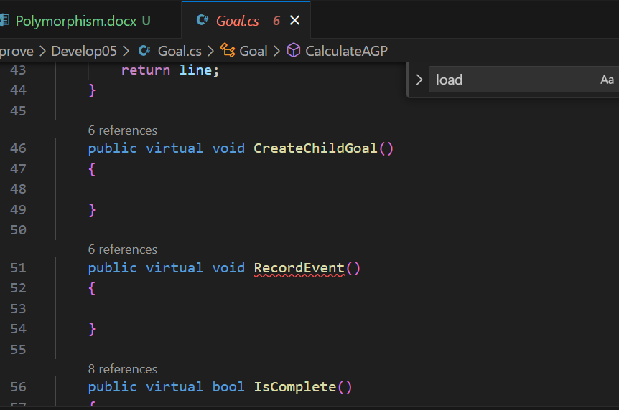

is overwritten in class SimpleGoal.cs

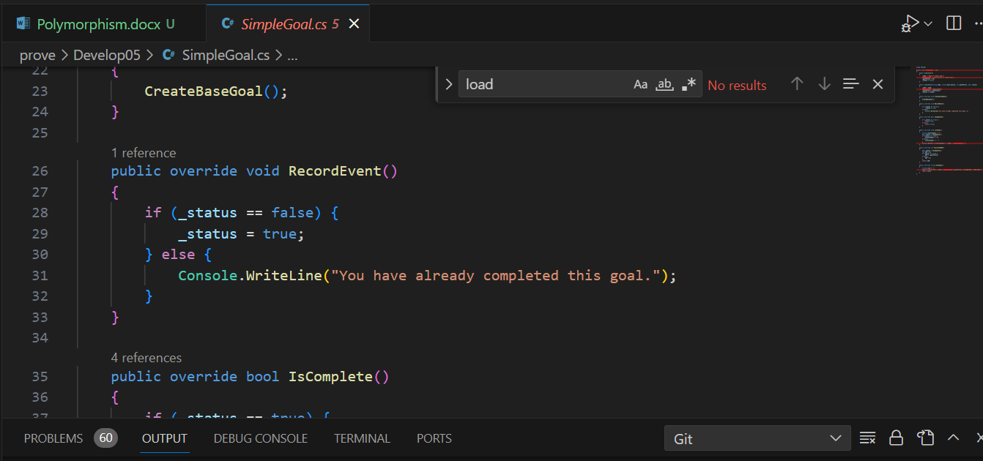

An in the others classes of goals

